Business Analysis Using SQL
select * from customer limit 20;

--Q1. What is the total revenue generated by male vs. female customers?

select gender, sum(purchase_amount) as revenu
from customer
group by gender;
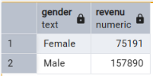

--Q2. Which customers used a discount but still spent more than the average purchase amount?

Select customer_id, purchase_amount
from customer
where discount_applied = ‘Yes’ and
purchase_amount >= (select avg(purchase_amount) from customer);
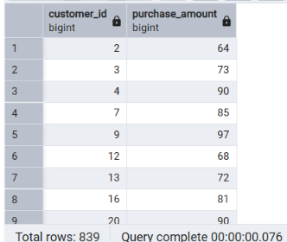

--Q3. Which are the top 5 products with the highest average review rating?

select item_purchased, round(avg(review_rating :: numeric), 2) as "Average product rating"
from customer
group by item_purchased
order by avg(review_rating) desc
limit 5;
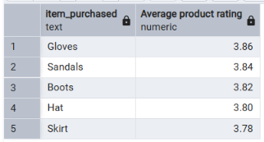

--Q4. Compare the average Purchase Amounts between Standard and Express Shipping.

Select shipping_type, round(avg(purchase_amount), 2)
from customer
where shipping_type in (‘Express’, ‘Standard’)
group by shipping_type;
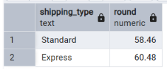

--Q5. Do subscribed customers spend more? Compare average spend and total revenue between subscribers and non-subscribers.

select subscription_status,
count(customer_id) as total_customers,
round(avg(purchase_amount), 2) as average_spend,
sum(purchase_amount) as total_revenue
from customer
group by subscription_status;
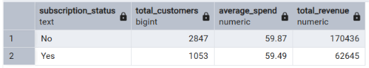

--Q6. Which 5 products have the highest percentage of purchases with discounts applied?
select item_purchased,

round(100 * sum(case when discount_applied = 'Yes' then 1 else 0 end)/count(*),2) as discount_rate
from customer
group by item_purchased
order by discount_rate desc
limit 5;
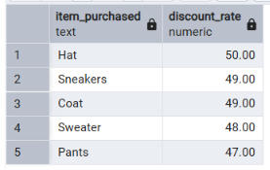

--Q7. Segment customers into New, Returning, and Loyal based on their total number of previous purchases, and show the count of each segment.

with customer_type as (
select customer_id, previous_purchases,
case
when previous_purchases = 1 then 'new'
when previous_purchases between 2 and 10 then 'returning'
else 'loyal'
end as customer_segment
from customer
)

select customer_segment, count(*) as "number of customer"
from customer_type
group by customer_segment
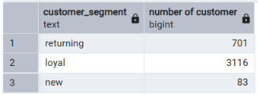

--Q8. What are the top 3 most purchased products within each category?

with item_counts as (
select category,
item_purchased,
COUNT (customer_id) as total_orders,
ROW_NUMBER() over (partition by category order by count(customer_id) DESC) as item_rank
from customer
group by category, item_purchased
)

select item_rank, category, item_purchased, total_orders
from item_counts
where item_rank <= 3;
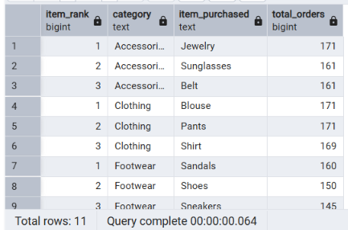

--Q9. Are customers who are repeat buyers (more than 5 previous purchases) also likely to subscribe?

Select subscription_status,
count(customer_id) as repeat_buyers
from customer
where previous_purchases > 5
group by subscription_status
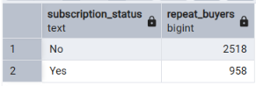

--Q10. What is the revenue contribution of each age group?

select age_group,
SUM (purchase_amount) as total_revenue
from customer
group by age_group
order by total_revenue desc;
